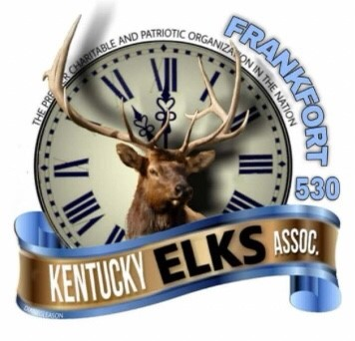
2021 FRANKFORT ELKS LODGE #530
ANNUAL CHARITY GOLF SCRAMBLE

___________ I would like to sponsor a golf hole.

Cost: $50 (Make checks payable to Frankfort Elks Lodge #530)

If you have a company logo and would like to include it on your sign, please provide us with a copy of it no later than September 15.

What would you like your sponsor sign to read?

___________________________________________________________________________

___________ I would like to donate a prize.

Description of prize: _________________________________________________________

Name of Business: __________________________________________________________

Address: __________________________________________________________________

City: _________________________ State: _____________ Zip Code: _______________

Contact Person: ____________________ Telephone Number: _______________________

Please mail sponsor sheet and check (if applicable) to:

Frankfort Elks #530 ATTN: Jennifer Hicks 309 Lewis Street Frankfort, KY 40601

