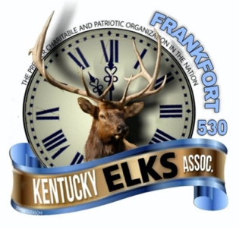Frankfort Elks Lodge #530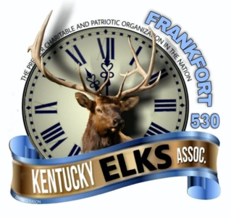
Annual Charity Golf Scramble

WHAT: 4-Person Team Handicap/Scratch Scramble (Male or Female)

WHEN: Saturday October 16, 2021 Lunch at 12:00pm, Shotgun Start at 1:00pm

WHERE: Juniper Hills Golf Course, Frankfort, KY

COST: $60 per person entry fee (includes lunch prior to play, green fees and cart)

Prizes will be determined by number entries. Handicap Maximum:
27 Team all Female or Mixed

Player One Handicap
25 Men
40 Ladies

If you have any questions, contact

Jennifer Hicks at (502) 298-9145
lodge at (502) 227-2913.

Address City, State Zip
Make checks payable to:

Frankfort Elks #530

And mail this form to:

Frankfort Elks #530 ATTN: Jennifer Hicks 309 Lewis Street
Frankfort, KY 40601

Player Two Handicap

Player Three Handicap

Player Four Handicap

If you are interested in playing and don’t have a team, please call or show up on tournament day and we will place you on a team. Please make every effort to sign up your team (with handicaps) prior to the day of the scramble.

